2A History/ USA 1917-1941: Document Study

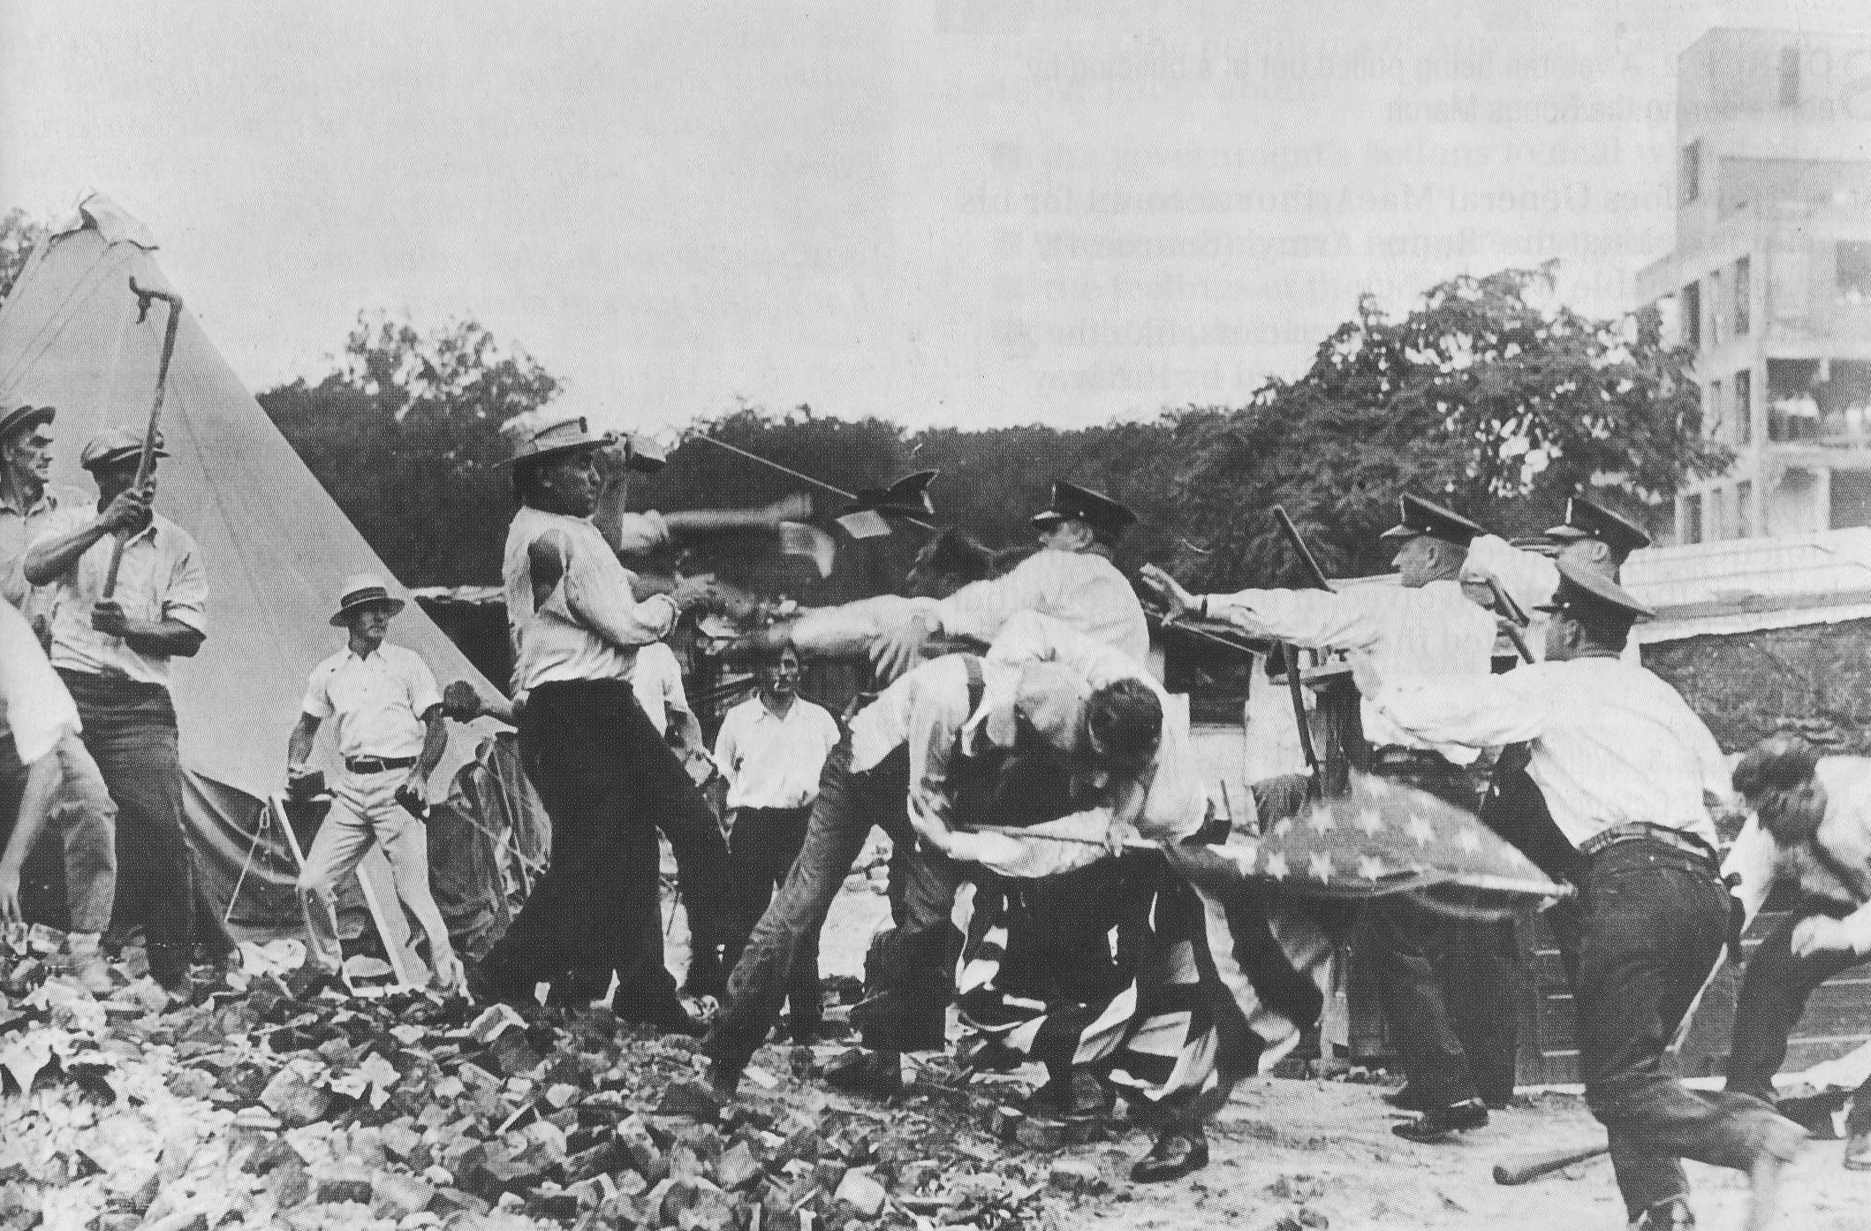

Source 1

Police attacking Bonus Marchers, 1932

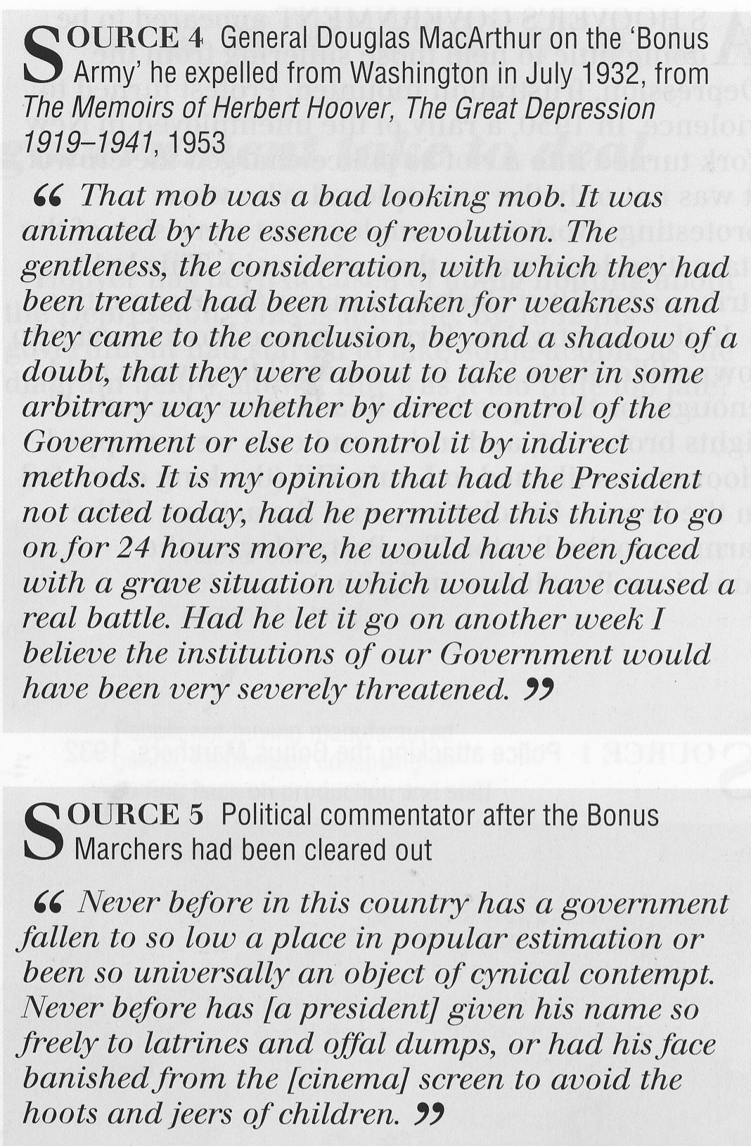
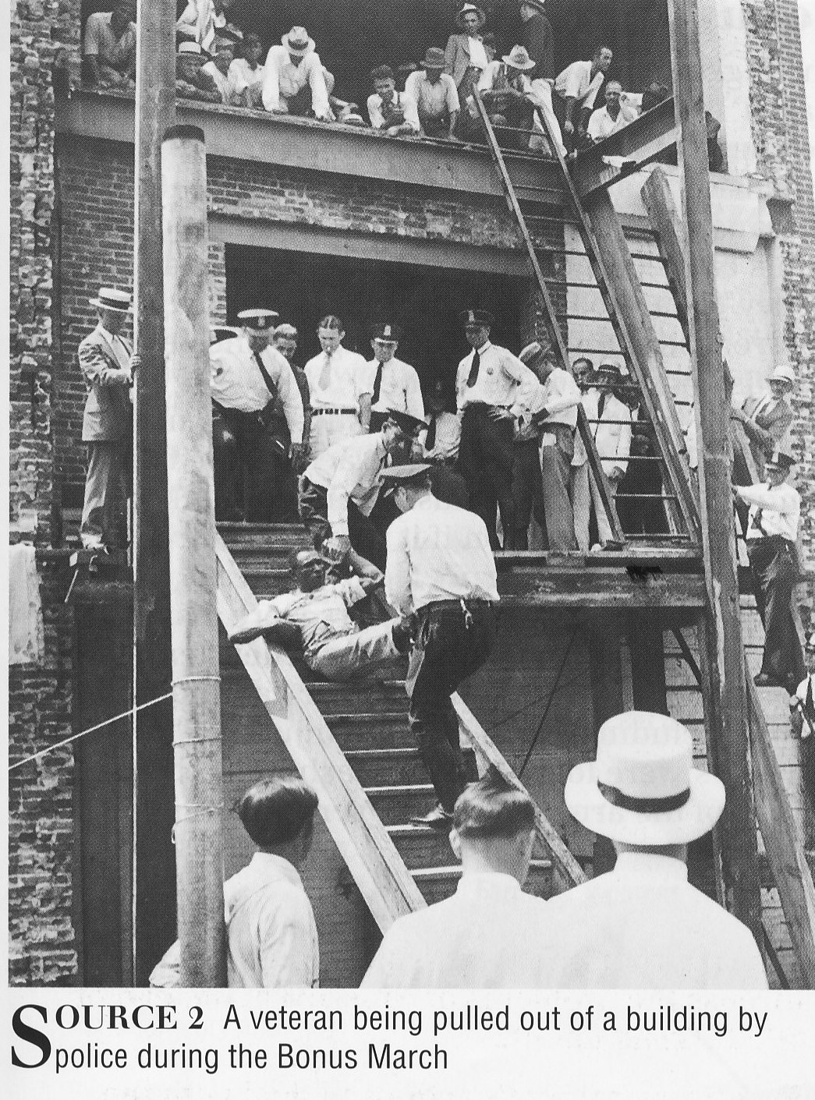

1. Refer to Sources 1 and 2 – What is the tone and message displayed in both sources? (4 marks)
________________________________________________________________________________________________________________________________________________________________________________________________________________________________________________________________________________________________________________________________________________________________________________________________________________________________________________________________________________________________________________________________________________________________________________________________________________________________________________________________________________________________________________________________________________

2. Of what value to historians are the photos of sources 1 and 2? Explain why. (2 marks)
____________________________________________________________________________________________________________________________________________________________________________________________________________________________________________________________________________________________________________________________________________________________________________________________________________________________________

3. Compare and Contrast the attitudes as displayed in sources 3 and 4. (3 marks)
____________________________________________________________________________________________________________________________________________________________________________________________________________________________________________________________________________________________________________________________________________________________________________________________________________________________________________________________________________________________________________________________________________________________

